**What is CSS?**

* CSS stands for Cascading Style Sheets.
* CSS helps elements how to be displayed on the web.
* CSS files the external style sheets which consist of the styles for HTML file.

**History of CSS**

Hakon Wium Lie released the first draft of “Cascading HTML Style Sheets” in October 1994. Although it took 3 years for any browser to come close to fully implementing CSS, August 1996 Microsoft Internet Explorer became the first browser to support CSS.

* The CSS 1 W3C Recommendation was made in December 1996.
* In May of 1998, the W3C released CSS 2 which added new capabilities including z-index, media types, bidirectional text, absolute, relative and fixed positioning, and support for aural style sheets.
* With the release of CSS 3, capabilities were broken into modules. Between June 2011 and June 2012, the following four modules were released as formal recommendations: color, selectors level 3, namespaces and media queries.

**Why Use CSS?**

CSS is used to style your web pages. Using CSS you will be able to put out pages with much less work, that load much faster, and will be easy to update and print!

**CSS Syntax**

Basic CSS rule consists of a selector and a declaration :

* CSS selector

All texts in <p> elements will blue:

p { color: blue; }

The selector points to the HTML element you want to style. In this example p is the selector for <p> elements in HTML file.

The declaration block contains one or more declarations separated by semicolons. In this example { color: blue; } is the declaration block.

Declarations must be surrounded by curly braces and end with a semicolon.

## **Use of CSS**

### External CSS file

The styles can be located in a different file, so with an external style sheet, the design of the website can be changed from this file.

To include an external stylesheet, <link> element must be used as a reference to the external style sheet in the <head> section of the HTML page.

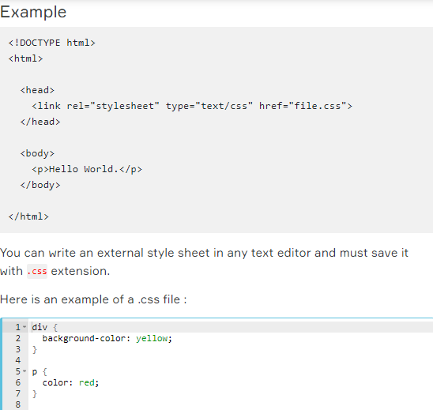

### Internal CSS

For any single HTML file, internal styles can be used. The internal styles are written inside the <style> section of the HTML page.

### Example

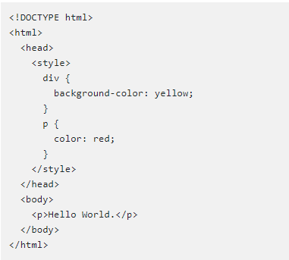

### Inline CSS

For any single element in the HTML file can have inline styles. For inline styling, the style attribute is used.

### Example

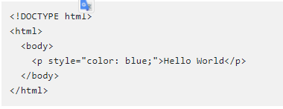

### Multiple Styles and Cascade Rule.

All styles which are applied to the same element will apply in the cascade order of rules.

Inline styles have the top priority, then external and internal style sheets and finally browser default styles. So, an inline style will override external and internal styles and browser defaults.

### Example

In the external style sheet, color of <p> is defined as red.  
  
file.css



In the internal style, color of <p> is defined as blue, and in the inline style yellow where the browser default is black. In this example, the color of <p> element will be yellow.

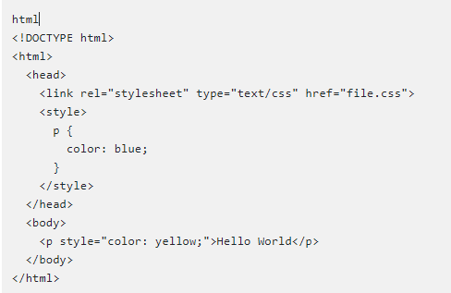

### The Box Model

All elements in the HTML file are considered as boxes. The "Box Model" term is used to describe a box that surrounds an element. It consists of: margins, borders, padding, and content.

Explanation of the different parts:

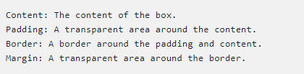

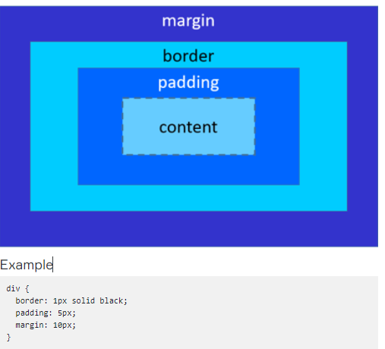

### CSS Selectors

CSS selectors are used to select HTML elements.

## **CSS element Selector:**

An element selector uses element name to select the HTML element.

### Example

p selector is used to select all <p> elements in the HTML file.

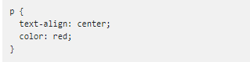

## **The CSS id Selector**

The id selector uses id attribute to select the element in HTML file.

The id of an element must be unique in a page. A hash (#) character is used to select an element with a specific id.

### Example

The HTML element with the id="text1" is selected:

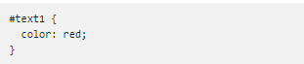

## **The CSS class Selector**

The class selector uses class attribute to select all elements of that class in HTML file.

A period (.) character is used to select elements with a specific class.

### Example

All HTML elements with the class="error" is selected:

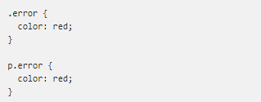

### The Universal Selector

The universal selector * selects all HTML elements on the page.

### Example

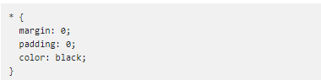

### CSS Comments

Comments are used to add an explanation of the code. Comments are ignored by browsers.

### Example

